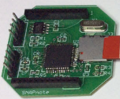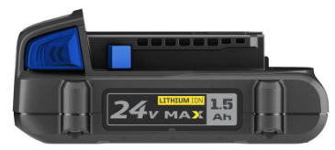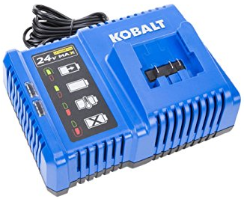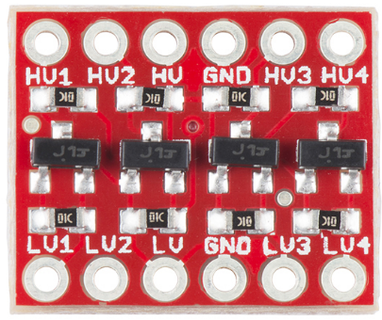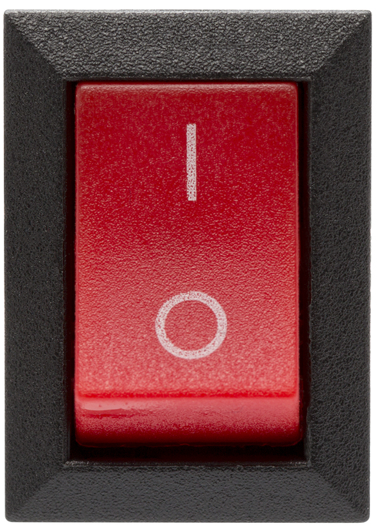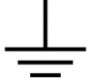

P19

P20

A1

A2

A3

A4

B1

B2

**3.3V**

**24V**

B3

B4

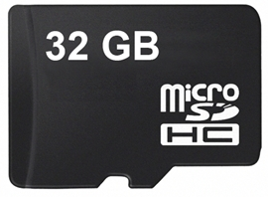

**3.3V**

P21

P22

P20

P21

P22

P19

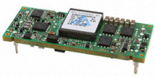

P30



P31

CPU B

CPU A



To LEDs

Power Switch

Level Shifters

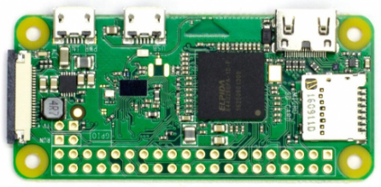

**5V**

**5V**



Pi Zero Wifi (Access Point)

P30

Level Shifters

DC/DC Converter

Battery and Charger

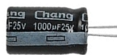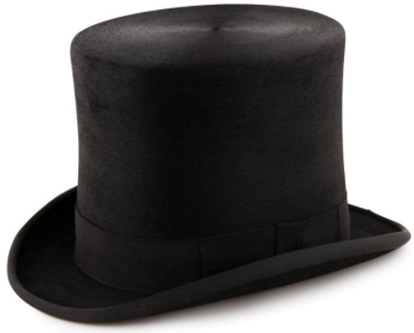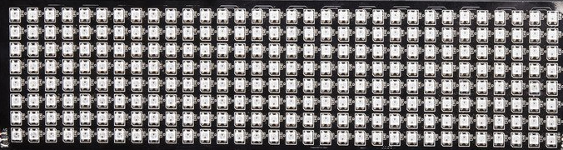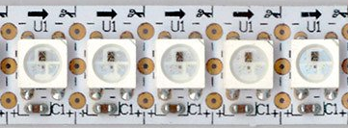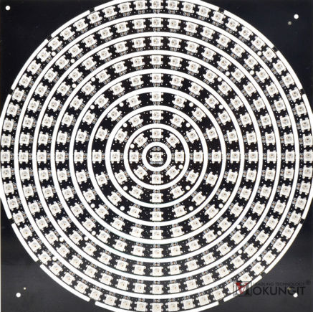

**5V**

A1

A3

A2

A4

B1

B2

B3

B4

241 pixels in the center of the top.

Four grids around the body. Each grid is 32*8 = 256 pixels.

54 pixels in short strips filling out the long axis of the top.

64 strips of 8 pixels wrapped around the brim. Divided into 2 sets of 256 pixels.

54 + 241 + 256*4 + 256*2 = 1831 total pixels

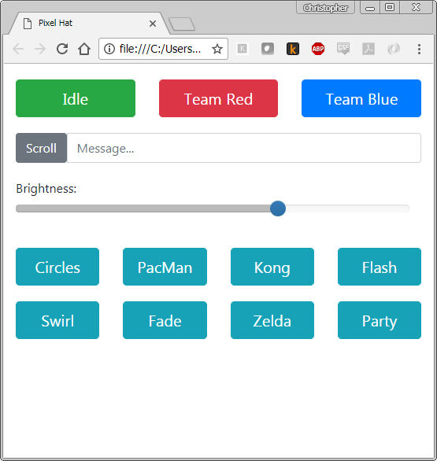

|  |  |  |
| --- | --- | --- |
| **URL** | **Action** | **PySerial String** |
| / (index.html) | The main application |  |
| /cgi/8 | Set the brightness (1 to 10) | “8<cr>” |
| /cgi/Idle | Play all animations (walking around mode) | “Idle<cr>” |
| /cgi/TeamRed | Match play as Team Red | “TeamRed<cr>” |
| /cgi/TeamBlue | Match play as Team Blue | “TeamBlue<cr>” |
| /cgi/Kong | Play the “Kong” animation sequence | “Kong<cr>” |
| /cgi/... | And so on. One button for each sequence | “...<cr>” |

HTTP

PySerial